SYMPTOTRACKAI: HYBRID RAG BASED SYMPTOM TRACKING AND HEALTH MONITORING SYSTEM
Conclusion, Future Scope and References
Department of Computer Science and Engineering, TKR College of Engineering & Technology
Batch C12 (CSE-C) · Academic year [ACADEMIC YEAR]
Table 1: Project team
S.No. | Student name | Roll number
1 | Mariyada Karthika Reddy | 23K91A05E9
2 | Nacharam Akshaya | 23K91A05G6
3 | Madoori Prabath Teja | 23K91A05D6
4 | Pulimadhi Keerthan | 23K91A05K1

Project guide: Dr. Ch. B. Naga Lakshmi
Chapter and section numbers quoted in the text (for example Chapter 8 or Section 6.2) refer to the full project report, 17.Final Document. Figures and tables in this document are numbered from 1.

1. CONCLUSION

1.1 Summary
SymptoTrackAI, implemented as the CareLens AI web application, lets a user describe symptoms in everyday language and returns grounded information about matching conditions. A FastAPI service normalises the text, expands it with a template, searches a 176-record knowledge base with FAISS and BM25, fuses the scores, reranks with a cross-encoder, builds an answer from the retrieved records, applies safety rules and stores the consultation in a private history. A React interface shows the answer, the evidence cards, the safety banners and the history. The whole system runs on one CPU-only PC.

1.2 Objectives achieved and key findings
Of the six objectives two are achieved, two are achieved with a stated qualification, one is partly met and one is not met beyond storage.
Table 2: Objectives against outcomes
No. | Status | Outcome
1 | Achieved (synthetic data) | 176 records, 30 conditions, FAISS and BM25 indexes
2 | Achieved | Free-text input with a rule-based expansion that gave no measurable benefit
3 | Achieved, measured | Top-1 96.7% on lay probes, 88.1% on two-symptom queries
4 | Partly | Answers built from retrieved records with evidence cards; no per-statement citation; generator echo
5 | Not achieved beyond storage | History saved, searched and deleted; no trends
6 | Partly | Retrieval and speed measured; groundedness checked structurally only

• The retrieval half works: 97.2% top-1 on verbatim leave-one-out, 96.7% on lay-language probes. The shipped 100% is an upper bound because the held-out record stays in the index.
• BM25 alone is a strong baseline on this synthetic data (88.3% on lay probes); the cross-encoder adds a little on paraphrase; the HyDE-style template adds nothing measurable.
• Three defects matter for a health tool: the default generator echoes its prompt (30 of 30), the relevance display says 100% even when nothing in the knowledge base matches, and the safety rules missed all 12 paraphrased emergencies.
• Against the base paper [1], which reports no figures, this project adds BM25 fusion, reranking, safety rules, an application with private history and a measurement; neither work is validated on real clinical data.
The most useful result of the evaluation is a negative one about the original evaluation. The shipped script reports 100% because it searches for records that are still in the index with their own symptom list as the query. Once the held-out record is removed the pipeline scores 96.7% on the same queries; with two random symptoms it scores 88.1%, and a team of four people writing everyday descriptions got 96.7%. None of these is a clinical accuracy, because the data are synthetic, but they are honest measures of how robust the retrieval is as queries move away from the stored text.
The ablation also shows where effort pays. The cross-encoder and the embedding model help on paraphrased input, and the TF-IDF fallback keeps the application usable offline (81.7% on lay probes). The HyDE-style template, which the project description lists as a core component, did not improve any set. We kept it in the shipped pipeline and report the result as measured.

1.3 Applications and known limitations
Applications: a teaching example of a hybrid RAG pipeline with its failure modes visible, a private first-look tool for symptom information once the knowledge base is replaced by reviewed content, and a base for a symptom-tracking product. Limitations: synthetic knowledge base, near-duplicate evidence, a relative relevance score, a wording-bound safety layer, no symptom trends, no user study. It is a prototype and must not be used for medical decisions.

1.4 What the project taught us
• A health assistant needs its failure modes measured before its accuracy: the missed paraphrased emergencies and the constant 100% matter more than another point of top-1.
• A pipeline with fallbacks can fail quietly: the echoing generator was reported as a success by the code, so a check on the output (not only on exceptions) is needed.
• A good-looking number needs its protocol read: the shipped 100% was correct arithmetic on a test that could not fail.
• Strong, simple baselines (BM25) are worth keeping in the comparison; they show which complexity pays for itself.
The results behind the key findings are shown below: how each retrieval configuration performs on the three harder query sets, and the evaluation protocol that produced the shipped 100% figure compared with leave-one-out and everyday-language queries.
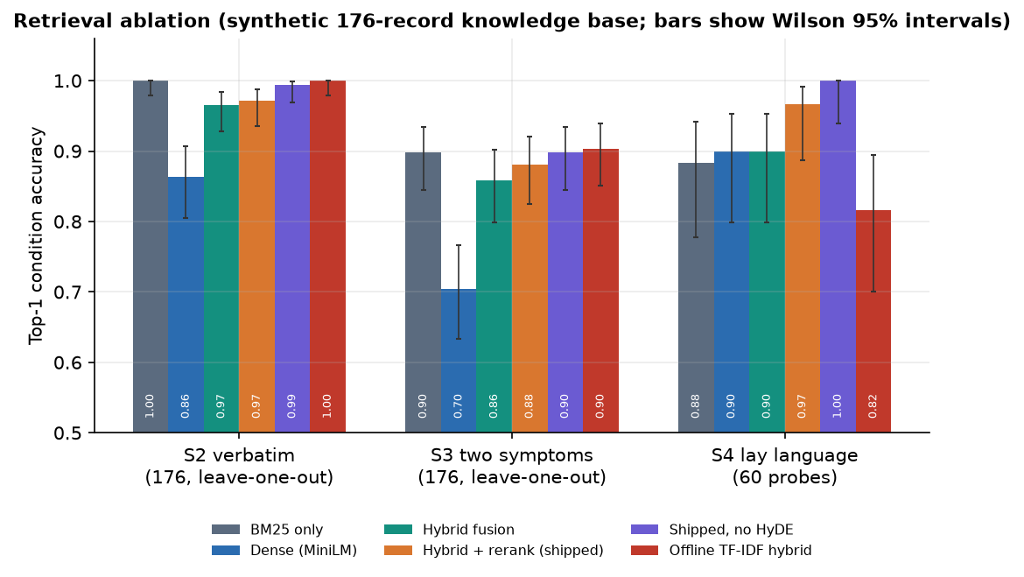
Figure 1: Top-1 condition accuracy of each retrieval configuration on verbatim, two-symptom and everyday-language queries.
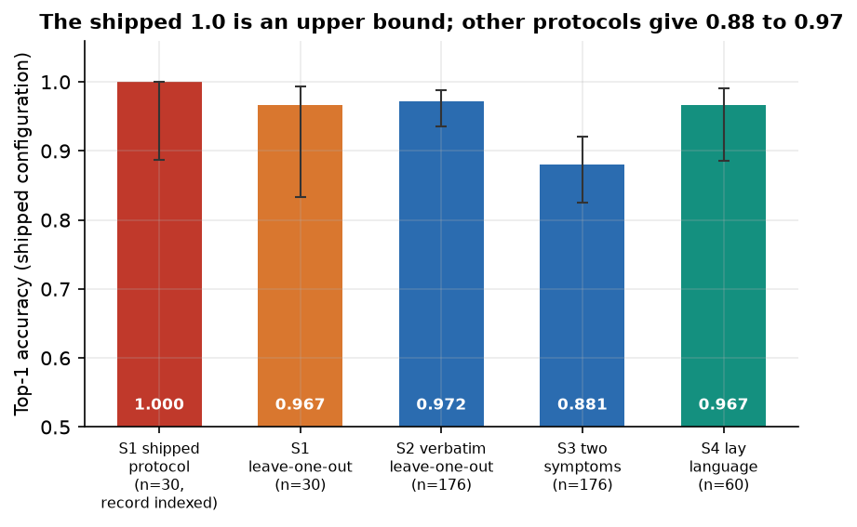
Figure 2: The shipped configuration under four evaluation protocols: the held-out record left in the index gives 100%, harder queries give less.

2. FUTURE SCOPE
The future work below follows directly from the measured weaknesses: first repair what exists, then add what the objectives promised and the base paper's gap statement called for, then prepare for real use, and finally evaluate with people.

2.1 Improvements to what exists
1. Repair generation. Load the T5 model with the sequence-to-sequence classes directly, or pin transformers below version 5, and detect an echoed prompt (output equal to input) so the fallback is used; then judge the generated answers.
2. Show absolute confidence. Use the raw cross-encoder score or a calibrated version, add an abstain threshold and say "no good match" for out-of-knowledge-base complaints; the raw score already separates the groups in our probes.
3. Diversify evidence. Collapse records of the same condition so the five cards show different conditions, giving a real differential.
4. Make the safety layer meaning-aware. Add negation and history handling, many more paraphrases, a small classifier trained on reviewed examples, and a test set written with clinicians; fix the case-sensitive filter and extend it to drug names.
5. Per-statement citations. Number each statement with its record id so objective 4 is met literally.
These five items are small in code but large in effect. Repairing generation and the uncertainty display would change what a user sees on every screen, and a meaning-aware safety layer is the precondition for any real use. Each can be checked with the harness already in the repository by re-running scripts/measure_metrics.py and comparing the new numbers with those in Chapter 8.

2.2 Additional features
• A symptom-tracking module for objective 5: structured symptom entries with severity and onset, a timeline, trend charts and a gentle alert when symptoms worsen.
• Follow-up questions about duration, severity and age, to narrow ambiguous two-symptom queries.
• Multilingual input and output, starting with Telugu and Hindi, using a multilingual encoder.
• Export of a consultation summary that a user can hand to a doctor.
• An evaluation page that shows the honest metrics of this report instead of the upper-bound figures.
The tracking module is the most important addition. The base paper's gap statement and objective 5 call for revealing progression and trends, but the application stores each consultation as an isolated free-text event. A structured symptom log (symptom, severity, onset, date) would let the system draw a timeline, compare the latest entry with earlier ones and retrieve guidance with that context.

2.3 Scalability and deployment
• Replace the synthetic table with reviewed content from licensed or open medical sources, at thousands of records, with an approximate FAISS index and source attribution per record.
• Run the API behind a production server with a persistent database, a managed secret key and rate limiting; the Docker files are a start.
• Cache the query embedding and reuse the pipeline across workers; consider a quantised or smaller reranker to cut the reranking cost.

2.4 Further research
• A user study with patients and clinicians on trust, comprehension and safety of the answers and escalation messages.
• A benchmark of symptom-description queries with expert-labelled conditions, to measure accuracy honestly and to compare retrieval-augmented and plain-model assistants [26, 28].
• Study of hallucination and refusal behaviour when a generator is actually working [27], and of fairness across languages and demographic descriptions.

3. REFERENCES
[1] U. S. Madhury and M. Ramesh, "A hybrid retrieval-augmented generation framework for intelligent symptom monitoring and disease guidance," Int. J. Eng. Res. Sci. Technol., vol. 22, no. 3, pp. 702-707, 2026, doi: 10.62643/ijerst.2026.v22.n3.4170.
[2] "A retrieval-augmented generation framework for medical question answering: design, implementation, and evaluation of an AI-driven healthcare chatbot," Iconic Research and Engineering Journals, 2026. [Listed in the batch literature survey; authors, volume and pages could not be verified.]
[3] "A book-verified retrieval-augmented medical chatbot for reliable and explainable healthcare assistance," in Proc. 7th Int. Conf. Intelligent Communication Technologies and Virtual Mobile Networks (ICICV), 2026. [Listed in the batch literature survey; authors and pages could not be verified.]
[4] "Healthcare chatbot: AI-powered medical information assistant using retrieval-augmented generation," Int. J. Pharmacy with Medical Sciences, 2026. [Listed in the batch literature survey; authors, volume and pages could not be verified.]
[5] N. Son, I. Kang, I. Kim, K. Lee, S. Nam and D. Lee, "Development and evaluation of a retrieval-augmented generation-based electronic medical record chatbot system," Healthc. Inform. Res., vol. 31, no. 3, pp. 218-225, Jul. 2025, doi: 10.4258/hir.2025.31.3.218.
[6] N. Nananukul and M. Kejriwal, "ClinicBot: a guideline-grounded clinical chatbot with prioritized evidence RAG and verifiable citations," system demonstration, CAIS 2026, arXiv:2605.00846, 2026.
[7] S. Divya, V. Indumathi, S. Ishwarya, M. Priyasankari and S. K. Devi, "A self-diagnosis medical chatbot using artificial intelligence," J. Web Develop. Web Designing, vol. 3, no. 1, pp. 1-7, 2018.
[8] S. S. Kumar, S. T. Ahmed, A. S. Fathima, M. Nishabai and S. Sophia, "Medical chatbot assistance for primary clinical guidance using machine learning techniques," Procedia Comput. Sci., vol. 233, pp. 279-287, 2024.
[9] I.-C. Hsu and J.-D. Yu, "A medical chatbot using machine learning and natural language understanding," Multimedia Tools Appl., vol. 81, no. 17, pp. 23777-23799, Jul. 2022.
[10] A. Babu and S. B. Boddu, "BERT-based medical chatbot: enhancing healthcare communication through natural language understanding," Explor. Res. Clin. Social Pharmacy, vol. 13, Art. no. 100419, Mar. 2024.
[11] S. D. Bhavani Peri, S. Santhanalakshmi and R. Radha, "Chatbot to chat with medical books using retrieval-augmented generation model," in Proc. IEEE North Karnataka Subsection Flagship Int. Conf. (NKCon), Bagalkote, India, Sep. 2024, pp. 1-5, doi: 10.1109/NKCON62728.2024.10774900.
[12] Prathwini and Prathyakshini, "PreScienceMED: leveraging text classification for precise disease prediction," in Proc. IEEE Int. Conf. Distributed Computing, VLSI, Electrical Circuits and Robotics (DISCOVER), Mangalore, India, Oct. 2024, pp. 90-95, doi: 10.1109/DISCOVER62353.2024.10750775.
[13] Y. Natarajan, K. R. S. Preethaa, S. Pandian, S. U. Geetha and S. Senthilkumar, "Enhancing medical information retrieval with a language model," in Proc. Int. Conf. Cognitive Robotics and Intelligent Systems (ICC-ROBINS), Coimbatore, India, Apr. 2024, pp. 437-441, doi: 10.1109/ICCROBINS60238.2024.10533903.
[14] S. H. Alqaidi, S. M. Albugami, W. S. Alzahrani, S. Badri and A. Wali, "Network-integrated medical chatbot for enhanced healthcare services," Telematics Informat. Rep., vol. 15, Art. no. 100153, Sep. 2024.
[15] P. Lewis et al., "Retrieval-augmented generation for knowledge-intensive NLP tasks," in Proc. Adv. Neural Inf. Process. Syst. (NeurIPS), vol. 33, 2020, pp. 9459-9474.
[16] V. Karpukhin et al., "Dense passage retrieval for open-domain question answering," in Proc. Conf. Empirical Methods Natural Language Process. (EMNLP), 2020, pp. 6769-6781.
[17] J. Johnson, M. Douze and H. Jegou, "Billion-scale similarity search with GPUs," IEEE Trans. Big Data, vol. 7, no. 3, pp. 535-547, Jul. 2021.
[18] N. Reimers and I. Gurevych, "Sentence-BERT: sentence embeddings using Siamese BERT-networks," in Proc. EMNLP-IJCNLP, 2019, pp. 3982-3992.
[19] S. Robertson and H. Zaragoza, "The probabilistic relevance framework: BM25 and beyond," Found. Trends Inf. Retr., vol. 3, no. 4, pp. 333-389, 2009.
[20] L. Gao, X. Ma, J. Lin and J. Callan, "Precise zero-shot dense retrieval without relevance labels," in Proc. 61st Annu. Meeting Assoc. Comput. Linguistics (ACL), 2023, pp. 1762-1777.
[21] R. Nogueira and K. Cho, "Passage re-ranking with BERT," arXiv:1901.04085, 2019.
[22] P. Bajaj et al., "MS MARCO: a human generated machine reading comprehension dataset," arXiv:1611.09268, 2016.
[23] H. W. Chung et al., "Scaling instruction-finetuned language models," J. Mach. Learn. Res., vol. 25, no. 70, pp. 1-53, 2024.
[24] W. Wang, F. Wei, L. Dong, H. Bao, N. Yang and M. Zhou, "MiniLM: deep self-attention distillation for task-agnostic compression of pre-trained transformers," in Proc. Adv. Neural Inf. Process. Syst. (NeurIPS), vol. 33, 2020, pp. 5776-5788.
[25] G. V. Cormack, C. L. A. Clarke and S. Buettcher, "Reciprocal rank fusion outperforms Condorcet and individual rank learning methods," in Proc. 32nd Int. ACM SIGIR Conf. Research and Development in Information Retrieval, 2009, pp. 758-759.
[26] G. Xiong, Q. Jin, Z. Lu and A. Zhang, "Benchmarking retrieval-augmented generation for medicine," in Findings Assoc. Comput. Linguistics: ACL 2024, 2024, pp. 6233-6251.
[27] Z. Ji et al., "Survey of hallucination in natural language generation," ACM Comput. Surveys, vol. 55, no. 12, Art. no. 248, 2023.
[28] K. Singhal et al., "Large language models encode clinical knowledge," Nature, vol. 620, no. 7972, pp. 172-180, 2023.
[29] T. Wolf et al., "Transformers: state-of-the-art natural language processing," in Proc. EMNLP: System Demonstrations, 2020, pp. 38-45.
[30] F. Pedregosa et al., "Scikit-learn: machine learning in Python," J. Mach. Learn. Res., vol. 12, pp. 2825-2830, 2011.
[31] C. D. Manning, P. Raghavan and H. Schutze, Introduction to Information Retrieval. Cambridge, U.K.: Cambridge Univ. Press, 2008.
[32] N. Provos and D. Mazieres, "A future-adaptable password scheme," in Proc. USENIX Annu. Tech. Conf., FREENIX Track, 1999, pp. 81-91.
[33] M. Jones, J. Bradley and N. Sakimura, "JSON Web Token (JWT)," IETF RFC 7519, May 2015.
[34] E. B. Wilson, "Probable inference, the law of succession, and statistical inference," J. Amer. Statist. Assoc., vol. 22, no. 158, pp. 209-212, 1927.
[35] S. Ramirez, "FastAPI," software, 2018. [Online]. Available: https://fastapi.tiangolo.com

